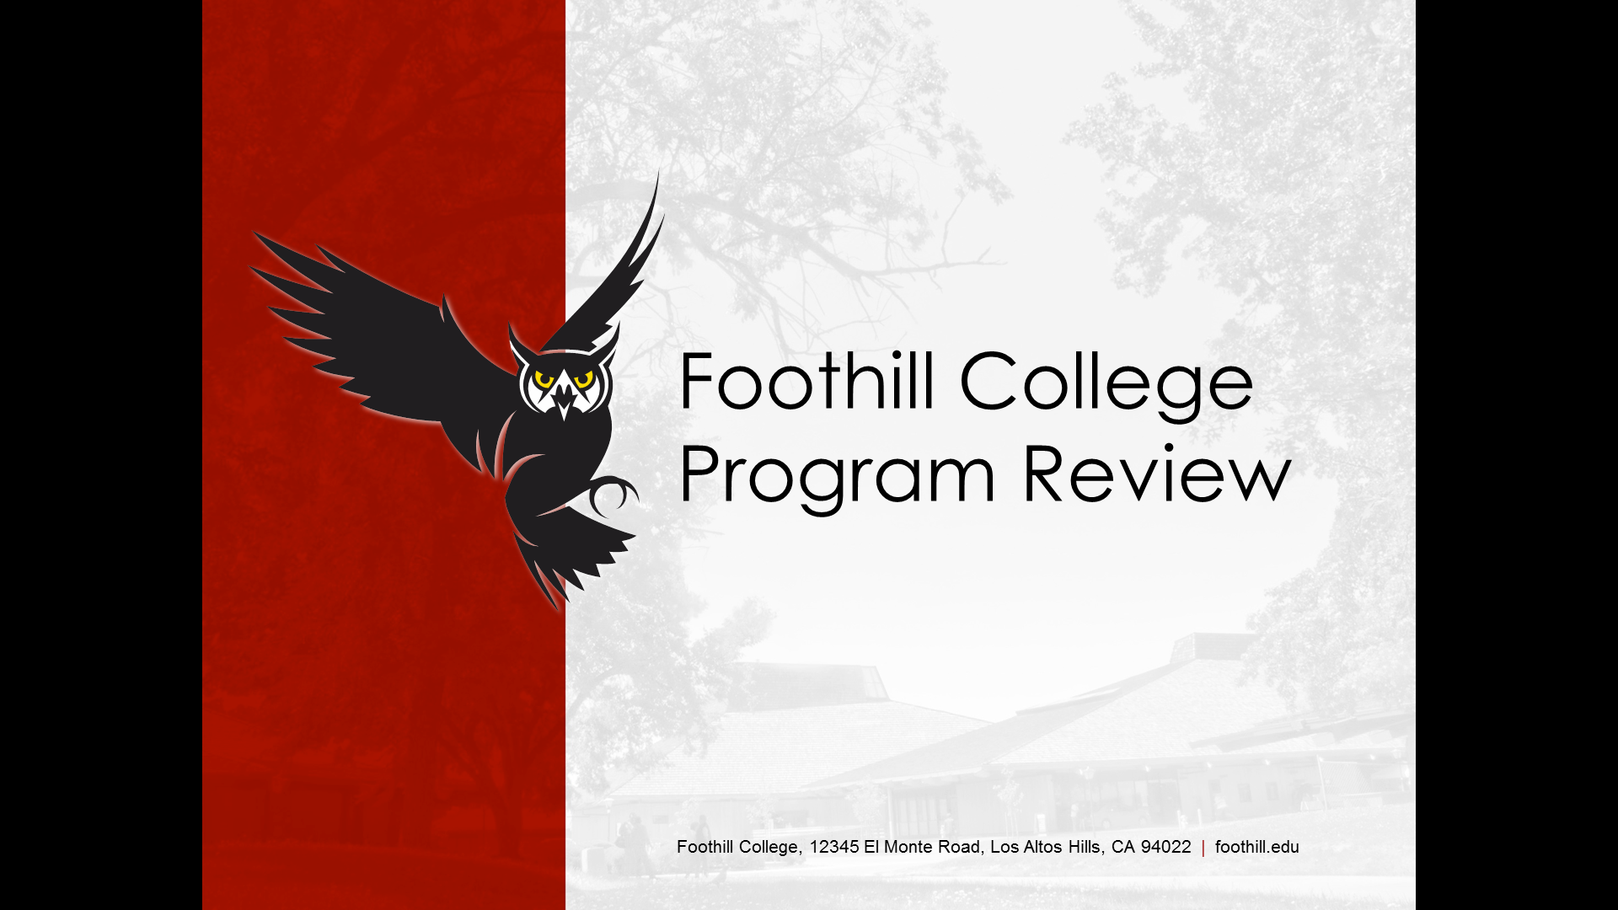

Foothill has amazing faculty, staff, administrators, and programs. Program Review is about documenting the discussions and plans you have for sustaining and improving student success in your program. It is also about linking your plans to decisions about resource allocations. Thank you for taking the time to review your program and sharing your findings with the college community!

Program Review Committee Members for 2017-18:
Andrew LaManque
Administrators
Paul Starer‎
Teresa Ong
Carolyn Holcroft
Faculty
Bruce Mc Leod‎
K Allison Meezan;
Craig Gawlick‎
Classified Staff
Jackie Brown
Melia Arken
Elaine Kuo (Ex Officio)

Let us know how we can help you!
https://foothill.edu/staff/irs/programplans/index.php

BASIC PROGRAM INFORMATION

Department Name:

Division Name:

Please list all team members who participated in this Program Review:
Name | Department | Position

Number of Full Time Faculty: |  | Number of Part Time Faculty:

Please list all existing Classified positions: Example: Administrative Assistant I

List all programs covered by this review and indicate the program type:
 | Certificate | AA / AS | AD-T | Pathway
 | Certificate | AA / AS | AD-T | Pathway
 | Certificate | AA / AS | AD-T | Pathway
 | Certificate | AA / AS | AD-T | Pathway
 | Certificate | AA / AS | AD-T | Pathway

Not sure? Check: https://foothill.edu/programs/ and click to sort using the “Areas of study/Divisions” button
Current pathways at Foothill College include: ESLL, NCEL, ENGL pathways (ENGL 209-110-1A; ENGL 209-1A; ENGL 1S/1T); MATH pathways (NCBS 401A/B; MATH 235-230-220-105; MATH 217-57).

SECTION 1: PROGRAM ENROLLMENT, PRODUCTIVITY, AND COMPLETION

Data for certificates and degrees will be posted on Institutional Research’s website for all measures except non-transcriptable completion.

1A. Analysis of Transcriptable Program Completion Data: Please use your data to complete the following table.

Transcriptable Program | Five-year trend in degrees/certificates awarded |  |  | Comments
e.g. Associate Degree for Transfer | The number AD-Ts awarded has been steadily increasing each year, up to a high of 39 degrees awarded in 16-17 | We are pleased to see this trend and believe it will continue as more students pursue AD-Ts
*according to CCCApply data

1B. Non-Transcriptable Program Data: If your program offers any non-transcriptable programs, please complete the following table. Institutional Research does not track this data; each program is responsible for tracking its own data.

Non-Transcriptable Program | Comments | Five-year trend | Rationale for program
e.g. Certificate of Proficiency in xx | We anticipate that this trend will continue because enrollment in the core classes for this certificate is holding steady | The number of completers has remained steady at around 9 per year | This credential boosts potential for job advancement in the xx industry. We receive positive feedback from employers (link to advisory committee minutes)

The 2017-18 College Strategic Objectives (E²SG) operationalize the college’s 3 EMP goals and include:

Equity– Develop an integrated plan; identify goals for alignment with equity, student success, and basic skills; and focus on efforts to integrate with enrollment strategies (access, retention, and persistence) to close equity gaps while increasing enrollments at the same.

Enrollment Growth – Achieve more than 1.5% FTES growth at 500 productivity (+/- 25) with attention to integrating equity efforts related to enrollment, CTE, and Sunnyvale Center.

1C. Course Enrollment: Enrollment is a count of every student who received a final grade (A, B, C, D, F, P, NP, W) in your program’s courses. It also serves as an indicator for program viability. Please use your program review data to examine your course enrollment trends and check the appropriate box below.

The link to the program review data tool can be found on the Employee tab of the portal:
myportal.fhda.edu (Program Review Application).

5-year Enrollment Trend: Increase Steady/No Change Decrease

Our college goal is to increase enrollment by 1.5% FTES this year. What steps might you take to increase the numbers of students enrolling in your courses? Steps might include cross department collaborations, actions to increase retention, service learning projects, support for student clubs, participation at recruitment events, examination of pre-requisites, review of assessment results, etc.

1E. Productivity: Productivity is a measure of students served per full-time equivalent faculty and is a factor in program viability. Please use your program review data sheet to examine your productivity trends and check the appropriate box below.

5-year Program Productivity Trend: Increase Steady/No Change Decrease

The college productivity goal is 500 (+-25). There are many factors that affect productivity (i.e. seat count/ facilities/accreditation restrictions, curriculum, etc.). Please discuss factors that may be affecting your program’s productivity trends and any plans you have for addressing the trends, especially if they are declining.

SECTION 2: COURSE COMPLETION & STUDENT ACHIEVEMENT

2A. Institutional Standard: This percentage represents the lowest course completion (success) rate deemed acceptable by the College’s accrediting body (ACCJC). The institutional standard during the year for which this program review is being written (2016-17) is 57%.
Please check the appropriate box:

Program Level Course Completion: Above Standard At Standard Below Standard

If your program’s course completion (success) rates are below the institutional standard (see above), please discuss your program objectives aimed at addressing this.

2B. Institutional Effectiveness (IEPI) Goal: This percentage represents an aspirational goal for course completion (success) rates; all programs should strive to reach/surpass this goal. The IEPI goal for which this program review is being written (2016-17) is 77%.
Please check the appropriate box:

Program Level Course Completion: Above Goal At Goal Below Goal

If your program’s course completion (success) rate is ABOVE the IEPI goal, please share your thoughts about why/how this is so (we hope to learn from your effective practices!).

2C. Course Success Demographics: Please examine the “Disproportionate Impact data by year” shared with your department and discuss actions you are taking, or plan to take, to address any achievement disparities identified in your program. If you are uncertain about actions faculty can take, please take a look at Appendix A.
https://foothill.edu/staff/irs/programplans/docs/appendix-a.pdf

Be sure to include the resources you need to implement or sustain your action plans in Section 3.

2E. Faculty Discussion: Course-Level Outcomes: Please share examples of how assessment and reflection of course-level Student Learning Outcomes (CL-SLOs) has led to changes in curriculum or teaching.

2E. Faculty Discussion: Program-Level Outcomes: Please provide examples of what is being done at the program-level to assist students in achieving your Program-Level Learning Outcomes, degree/certificate completion, and/or transferring to a four-year institution (e.g. review of progress through the program, “career days”/open houses, mentoring, education pathways (clear, structured academic program maps (suggested courses for each term) for all academic programs), etc.). If your program has other program-level outcomes assessments (beyond SLOs and labor market data), discuss how that information has been used to make program changes and/or improvements.

Please attach Course and Program-Level Outcomes (Four Column Report from TracDat).
Contact the Office of Instruction if you need help.

If your department has a Workforce/CTE program, please complete Section 2F.
If your department does not have a Workforce/CTE program, please skip to Section 3.

2F. Workforce/CTE Programs: Refer to the program review website for labor market data.

What is the regional five-year projected occupational growth for your program?

What is being done at the program-level to meet/adjust to the projected labor market changes?

What is being done at the program-level to assist students with job placement and workforce preparedness?
Be sure to include the resources you need to implement or sustain your action plans in Section 3.

SECTION 3: SUMMARY OF PROGRAM OBJECTIVES & RESOURCE REQUESTS

3A. Past Program Objectives: Please list program objectives (not resource requests) from past program reviews and provide an update by checking the appropriate status box.
 | Year: | Completed | Ongoing | No Longer a Goal
 | Year: | Completed | Ongoing | No Longer a Goal
 | Year: | Completed | Ongoing | No Longer a Goal
 | Year: | Completed | Ongoing | No Longer a Goal
 | Year: | Completed | Ongoing | No Longer a Goal

Please comment on any challenges or obstacles with ongoing past objectives.

Please provide rationale behind any objectives that are no longer a priority for the program.

3B. Current Program Objectives and Resource Requests: Please list all new and ongoing program objectives based on discussion in Sections 1 and 2, including your objectives to eliminate any achievement disparities in course success for student subgroups (Section 2A). If additional resources are needed, indicate them in the table below. Refer to the Operations Planning Committee (OPC) website for rubrics and resource allocation information.
Resource Request | Program Objective | Implementation Timeline | Progress Measures | Resource Type Requested* | Estimated cost
 | Example: Offer 2 New Courses to Meet Demand | Winter 2016 Term | Course Enrollment
*Resource type should indicate one of the following: One-time B-budget; Ongoing B-budget augmentation; Facilities/Equipment; New faculty/staff.

3C. Faculty/Staff Position Requests: Please describe the rationale for any new faculty or staff positions your program is requesting:

3D. Unbudgeted Reassigned Time: Please list and provide rationale for requested reassign time.

3E. Please review any resource requests granted over the last five years and whether it facilitated student success.

SECTION 4: PROGRAM SUMMARY

4A. Prior Feedback: Address the concerns or recommendations made in prior program review cycles, including any feedback from the Dean/VP, Program Review Committee (PRC), etc.
Concern/Recommendation | Comments

4B. Summary: What else would you like to highlight about your program (e.g. innovative initiatives, collaborations, community service/outreach projects, etc.)?

SECTION 6: FEEDBACK AND FOLLOW-UP

This section is for the Dean/Supervising Administrator to provide feedback.

6A. Strengths and successes of the program as evidenced by the data and analysis:

6B. Areas of concern, if any:

6C. Recommendations for improvement:

6D. Recommended Next Steps:
Proceed as Planned on Program Review Schedule
Further Review / Out-of-Cycle In-Depth Review

This section is for the Vice President/President to provide feedback.

6E. Strengths and successes of the program as evidenced by the data and analysis:

6F. Areas of concern, if any:

6G. Recommendations for improvement:

6H. Recommended Next Steps:
Proceed as Planned on Program Review Schedule
Further Review / Out-of-Cycle In-Depth Review

Upon completion of Section 6, the Program Review document should be returned to department faculty/staff for review, then submitted to the Office of Instruction and Institutional Research for public posting. Please refer to the Program Review timeline.

