Foothill College
Credit Program Narrative
Transcriptable Certificate of Achievement:
Data Analytics

Item 1. Program Goals and Objectives

The goal of the Data Analytics Certificate is to offer practical training in the most essential skills and tools used by businesses and organizations to analyze data to find actionable insights, and drive data-based decisions to increase business success. The demand for data professionals -- who are fluent in the latest data analytics techniques and methods combined with the business acumen needed to apply their skills strategically in today’s business environment – has never been greater and promises to be a rich source of career opportunity for the foreseeable future. With a strong focus on students from diverse populations, the Data Analytics Certificate will provide individuals with an opportunity to benefit from the strong growth in data analytics job positions that require the skills offered by this certificate.
Program Learning Outcomes:
- Upon completion of the program, the student will have acquired the necessary basic skills to conduct data analytics projects in a typical business environment.
- Upon completion of the program, the student will be able to demonstrate appropriate critical thinking, problem-solving skills and communication skills to contribute to effective data analytics in a business organization.

Item 2. Catalog Description

Created in collaboration with Silicon Valley Bank and Tableau, the Data Analytics Certificate is designed for people who are seeking to gain real-world experience in data analytics in pursuit of a career as a data professional. The program provides 23 units of instruction and hands-on practice in (1) understanding data needs of a business, (2) in acquiring, cleaning, storing, sorting, visualizing, analyzing, & presenting data, and (3) in positively impacting business outcomes through data analytics.

Item 3. Program Requirements

Requirements | Course # | Name | Units | Sequence
Core Courses  (23 units) | BUSI 11  BUSI 12  CS 31A  CS 48A  MATH 10 | Intro to Information Systems  Intro to Data Analytics & Business Decisions  Intro to Database Management Systems  Data Visualization  Statistics | 5  4  4.5  4.5  5 | Fall, Year 1  Winter, Year 1  Spring, Year 1  Spring, Year 1  Fall, Year 2

TOTAL UNITS: 23 units

Item 4. Master Planning

Foothill College offers programs and services that empower students to achieve their goals as members of the workforce, as future students, and as global citizens. There is currently a high demand for qualified individuals who understand data analytics and can utilize them to benefit an organization.
This innovative program will allow students to achieve their goals whether it is to promote their business, advance in place of employment or transfer credit to a four-year college. The Data Analytics Certificate is also a pivotal step for students who are retraining, returning to workplace and/or updating marketing skills.

Item 5. Enrollment and Completer Projections

On average, BUSI 11, CS 31A, and MATH 10 have been offered consistently for the past 4 years (2016-2020), with consistent enrollment in all classes over the same period of time. While BUSI 12 and CS 48A have only been offered starting Winter 2020, initial student interest is extremely high for both of these courses. Due to high demand for data analytics skills in the marketplace as well as the highly visible partnership with Tableau and Silicon Valley Bank, we are confident that enrollment will grow for all course in the certificate. Also, the relatively compact nature of the certificate will be extremely attractive to individuals who wish to employ the newly acquired skills in their current roles. Further, because all of the courses can be taught online complete, if needed, it is anticipated that international participation over the next five years will significantly increase the number of students who complete this certificate.

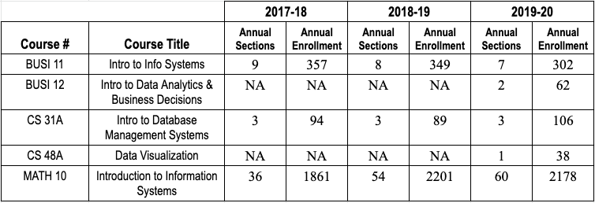

Item 6. Place of Program in Curriculum

Foothill College currently offers all courses necessary to complete the Data Analytics Certificate. Students will be able to complete the coursework as early as Spring 2021. The new transcriptable Data Analytics Certificate will be available to students as soon as it is approved.

Item 7. Similar Programs at Other Colleges in Service Area

There are six community colleges in the Bay Region issuing 62 awards on average annually (last 3
years) on TOP 0708.00 - Computer Infrastructure and Support. Gavilan College is the only college in the
Silicon Valley Sub-Region issuing an award on this TOP code, issuing one award on average annually
(last 3 years). It is important to note that TOP 0708.00 - Computer Infrastructure and Support, is a
program of study that would be preparing students for not only Data Science Occupations, but a cluster
of other occupations more traditionally aligned with Computer Infrastructure and Support. [Updated LMI Information will be incorporated to further support this application]

The Foothill collaboration with Tableau and Silicon Valley Bank provides significant differentiation for our Data Analytics Certificate from any competitor. Additionally, the Foothill certificate focuses on practical application data analytics skills.

Canada College is working on developing a similar certificate. No comparable certificate is offered by a community college in California at this time.

Additional Information Required for State Submission:

TOP Code: 0509.70 – E-Commerce (business emphasis) Programs that combine marketing and management principles with technical applications of the Internet and World Wide Web, with main emphasis on business principles.

Annual Completers: 40

Net Annual Labor Demand: See report

Faculty Workload: .6 annual load or 60% of one FTEF.

New Faculty Positions: None, our existing full-time and adjunct faculty will teach the courses.

New Equipment: $0

New/Remodeled Facilities: $0

Library Acquisitions: $0

Gainful Employment: Yes

Program Review Date: December 2021

Distance Education: This is the percentage of program courses conducted online; choose from the following: 0% 1-49% 50-99% 100%

Additional Information:

ATTACH THE FOLLOWING:

- Employment data and projections.
- Advisory Committee Recommendation (includes advisory committee membership, minutes, and summary of recommendations)
- Regional Consortia Approval Meeting Minutes (showing program recommendation)

